MOUNT KENYA UNIVERSITY

SCHOOL OF COMPUTING AND INFORMATICS
DEPARTMENT OF INFORMATION TECHNOLOGY/ENTERPRISE COMPUTING

PROJECT TITLE: THIKA VARSITY LAST MILE ESHOP

BY: EMMANUELI MURIUKI
BIT/2024/61120

This project is submitted in partial fulfilment of requirement for the Mount Kenya
University award of BACHELOR OF SCIENCE IN INFORMATION TECHNOLOGY

DECLARATION
I hereby declare that this project report is based on my original work except for citations and quotations which have been duly acknowledged. I also declare that it has not been previously and concurrently submitted for any other degree or award at Mount Kenya University

Name: EMMANUELI MURIUKI ADM No: BIT/2024/61120
Signature:
Date:

SUPERVISOR
I the undersigned do hereby certify that this is a true report for the project undertaken by the above named student under my supervision and that it has been submitted to mount Kenya
University with my approval
Name: MUCHIRI NYAGA

Signature……………………………………………………. Date…………………………….

Contents
DECLARATION 2
CHAPTER ONE: INTRODUCTION 6
1.1 Introduction 6
1.2 Background of the Study 6
1.3 Problem Statement 8
1.4 Proposed Solution 8
1.5 Objectives of the Study 8
1.6 Research Questions 9
1.7 Justification 9
1.8 Scope and Limitation of the Study 9
1.9 Risk and Mitigation 9
1.9.1 Budget 10
1.9.2 Schedule 11
CHAPTER TWO: LITERATURE REVIEW 12
2.1 Introduction 12
2.2 Objective I: Landmark-Based Navigation and Location-Based Services (LBS) 12
2.3 Objective II: Dual-Marketplace and Recommendation Module 13
2.5 Research Gaps 15
CHAPTER THREE: METHODOLOGY 16
3.0 Introduction 16
3.1 Research Philosophy and Approach 16
3.2 Research Design 16
3.3 Target Population 17
3.4 Sampling Technique 17
3.5 Data Collection Methods 17
3.5.2 Secondary Data Collection 17
3.5.3 Data Validity and Reliability 18
3.6 Data Analysis and Presentation Methods 18
3.7 System Feasibility Analysis 18
3.7.1 Technical Feasibility 18
3.7.2 Operational Feasibility 18
3.7.3 Economic Feasibility 18
3.8 System Design Diagrams 19
3.8.1 Context Diagram 19
3.9 Implementation Techniques 21
3.9.1 System Implementation and Testing Tools 21
4.0 Time Schedule and Project Cost 22
4.1 Ethical Considerations 22
4.1.1 Limitations of the Study 22
4.1.2 Summary of the Research Methodology 22
CHAPTER FOUR: SYSTEM ANALYSIS AND REQUIREMENT MODELLING 23
4.0 Introduction 23
4.1 Analysis of the Current System 23
4.2 Data Gathering Methods 24
4.2.1 Questionnaires 24
4.2.2 Structured Interviews 24
4.2.3 Direct Observation 24
4.3 Fact Finding Results 25
4.3.1 Navigation and Delivery 25
4.3.2 Payment Trust and Security 25
4.3.3 Student Second-Hand Trading 25
4.3.4 Platform Gap in the Market 26
4.4 Functional Requirements 26
4.4.1 User Management and Verification 26
4.4.2 Landmark-Based Navigation 26
4.4.3 Dual Marketplace 27
4.4.4 Escrow Payment Module 27
4.4.5 In-App Communication and Administration 27
4.5 Non-Functional Requirements 27
4.5.1 Performance 27
4.5.2 Security and Legal Compliance 28
4.5.3 Usability 28
4.5.4 Reliability and Maintainability 28
4.6 System Modelling Diagrams 28
4.4.4 System Design Diagrams 28
Context Diagram 28
4.6.2 Sequence Diagram: Payment and Escrow Flow 29
4.7 Chapter Summary 31
CHAPTER FIVE: SYSTEM DESIGN 32
5.0 Introduction 32
5.1 System Architecture 32
5.2 Module Implementation 32
5.2.2 Landmark-Based Pin-Drop Navigation Module (Objective I) 34
5.2.3 Dual-Marketplace Module (Objective II) 35
5.2.4 Secure Escrow Payment Module (Objective III) 37
5.2.5 In-App Chat and Moderation Module 39
5.2.6 Subscription and Analytics Module 40
5.3 Database Design 42
5.3.1 Conceptual Database Design 42
5.3.2 Logical Database Design 42
5.3.3 Physical Database Design 43
CHAPTER SIX: SYSTEM IMPLEMENTATION 44
6.0 Introduction 44
CHAPTER SEVEN: LIMITATIONS, CONCLUSIONS AND RECOMMENDATIONS 49
7.0 Introduction 49
7.1 Limitations 49
7.2 Conclusions 49
7.3 Recommendations 49
References 50
APPENDIX A: SAMPLE SYSTEM SOURCE CODE 53
A.1 Project Organizational Structure 53
A.2 Research Instruments and Documents Reviewed 53
A.3 Data Collection Instruments & Survey Questionnaires 54
A.4 Sample System Source Code 57

CHAPTER ONE: INTRODUCTION

1.1 Introduction
The Thika Varsity Last Mile E-Shop system is a specialized Android-based platform developed using Kotlin, designed to fundamentally re-engineer the localized e-commerce landscape for the student and residential community in Thika. This project entails the creation of a comprehensive digital ecosystem that addresses the unique socio-economic and logistical fabric of a student- heavy town. At its core, the project involves the development of a landmark-integrated navigation system that bypasses the limitations of traditional GPS in unmapped residential areas, ensuring that products can reach the most remote doorsteps in estates like Landless and Kiganjo. Furthermore, the system will entail a sophisticated dual-marketplace architecture; it is designed to facilitate the primary sale of essential goods from local vendors to students while simultaneously hosting a secure, formal environment for peer-to-peer "Student Exchanges." This second-hand economy module will allow students to both buy and sell pre-loved academic and lifestyle essentials, such as textbooks and electronics, effectively creating a circular economy within the campus environment. To ensure financial security and cultural relevance, the project integrates the M-Pesa Daraja API for instantaneous mobile transactions and implements a localized escrow service to protect against fraud in second-hand trades. Beyond the technical code, the project entails a deep focus on User Experience (UX) optimization for low-end smartphones, ensuring that the application remains responsive and accessible even on limited data bundles or 3G networks. The final system will serve as a digital bridge, connecting small- scale "Mama Mboga" traders and student entrepreneurs with a vast, previously unreachable customer base, thereby fostering economic resilience and logistical efficiency across the entire Thika Varsity ecosystem.

1.2 Background of the Study
Thika is an industrial municipality located in Kiambu County, approximately 42 kilometers northeast of Nairobi, Kenya (Wikipedia, Thika, 2026). Strategically positioned along the busy Nairobi-Thika highway, Thika serves as a major economic hub characterized by numerous manufacturing industries, agricultural processing plants, and a growing service sector
(Government, 2026). The town hosts several higher education institutions, including Mount
Kenya University (Wikipedia, Mount Kenya University, 2025), Thika Technical Training Institute, and numerous private colleges, attracting a substantial student population that contributes significantly to the local economy. (Today, The story of Kiandutu slums – Thika’s hidden heartbeat, 2025) Thika's peripheral estates such as Landless, Kiganjo, and Kiandutu accommodate a large proportion of students and low-income residents who have settled in these areas due to relatively affordable housing (Today, 2026). In these remote estates, residents and students engage in buying and selling goods through informal channels (Capital, 2025). Sellers advertise items using WhatsApp groups, Facebook Marketplace, or physical notice boards on campus and in local shops (Moyo, 2026). Buyers rely on word-of-mouth recommendations or spend considerable time scrolling through group chats to find what they need (Kenya, 2024). When a transaction is agreed upon, buyers must physically travel to meet sellers or rely on vague directions referencing informal landmarks such as "near the blue water tank" or "opposite the church. (SimpetCargo, 2025)" Deliveries frequently fail because couriers cannot locate addresses, leading to cancelled transactions and frustration. Payment is conducted through informal M-Pesa transfers without any protection mechanism, exposing both parties to fraud (PLC, 2024). The absence of formal addressing systems in these peripheral estates creates significant challenges for service delivery, emergency response, and commercial logistics (Capital, 2025).

1.3 Problem Statement
The primary challenge in Thika’s digital trade is the geographical exclusion of residents in remote estates like Landless and Kiganjo, who face frequent "Last Mile" delivery failures because riders cannot easily locate their homes (Kenya R. o., 2024) (Kenya D. , 2024). Furthermore, while the second-hand economy is essential for the student population, it is currently inefficient and untrusted; buyers fear receiving poor-quality items, and students have no structured way to sell their used essentials back into the market (Wangari, 2019). This lack of a localized escrow system and deep M-Pesa STK integration means that trade in Thika’s peripheral areas remains risky, slow, and largely manual (PLC, 2024)l.

1.4 Proposed Solution
The proposed Thika Varsity Last Mile E-Shop is an integrated Android-based marketplace developed in Kotlin that provides a landmark-based "Pin-Drop" navigation feature to ensure precise delivery to unmapped hostels in Landless and Kiganjo, alongside a dual-sided marketplace that enables both the primary sale of new goods and a verified peer-to-peer exchange for students to buy and sell second-hand essentials. This solution incorporates a localized escrow payment gateway via the M-Pesa Daraja API, ensuring funds are only released upon physical verification of goods, and features a lightweight "Vendor Mode" that allows local small-scale traders to gain digital visibility and reach remote customers without requiring high- end hardware or advanced technical skills.

1.5 Objectives of the Study

1.5.1 General Objective
To design and develop a localized Android application that enables remote delivery access and facilitates a secure dual-sided second-hand economy in Thika.

1.5.2 Specific Objectives
- To create a system that implements a landmark-based "Pin-Drop" navigation module for identifying, mapping, and validating student hostel landmarks in Landless and Kiganjo, achieving location accuracy within 10 meters and at least 90% successful last-mile delivery navigation during field testing, within a period of 6 months.
- To develop a system that will feature a dual-marketplace interface allowing users to securely toggle between "Buyer" and "Seller" roles to facilitate the verified exchange of academic and household essentials.
- To design a system that will integrate a secure payment and escrow module using the M- Pesa Daraja API to hold funds until transaction completion is verified by both parties.

1.6 Research Questions
- Will the system integrate a landmark-based navigation system and reduce the rate of failed deliveries in unmapped areas like Kiganjo and Landless?
- Will the system have escrow features necessary to build a secure "buying and selling" ecosystem that protects students from fraud in the second-hand market while?
- Will the system utilize M-Pesa STK Push integration in improving transaction speeds for remote customers?

1.7 Justification
This project is justified as it provides a vital logistical bridge for residents of Landless and Kiganjo, allowing them to access goods without expensive commutes, while simultaneously empowering students to safely recoup value from used items and providing small-scale Thika traders with a digital storefront to reach an expanded, previously inaccessible audience.

1.8 Scope and Limitation of the Study
The Thika Varsity Last Mile E-Shop system provides a comprehensive mobile marketplace for the Thika town environs, focusing on user authentication, landmark-based ordering for hostels in Landless and Kiganjo, and a dual-marketplace for new and used goods with integrated M-Pesa payments. However, the system is limited in that it cannot facilitate inter-county deliveries, as it is strictly optimized for the Thika hyper-local landmark ecosystem, and it will not support offline payment processing, requiring an active internet connection for real-time M-Pesa STK push notifications.

1.9 Risk and Mitigation
During the development and implementation phases, a significant risk encountered is the potential for database synchronization errors when users in areas with fluctuating connectivity attempt to post listings, which is mitigated by implementing an "Offline-First" Room database architecture that syncs data automatically once a stable connection is restored. Another critical risk is the threat of fraudulent second-hand listings appearing on the platform; this is mitigated by requiring all sellers to link their accounts to a verified student ID and holding M-Pesa payments in a system-controlled escrow until the buyer confirms physical receipt of the item at the designated landmark.

1.9.1 Budget

SNO | Item | Quantity | Cost Per Unit | Total Cost
1 | Laptop | 1 | 30000 | 30000
2 | Windows OS | 1 | 1000 | 1000
3 | Firebase Db | 1 | Free | Free
4 | Android Studio | 1 | Free | Free
5 | Android phone | 1 | 15000 | 15000
6 | Miscellaneous |  | 10000 | 10000
7 | Antivirus | 1 | 5000 | 5000
Total cost |  |  |  | 61000

1.9.2 Schedule

Time  Activity | Jan  2026 | uary | February  2026 |  | March  2026 | April  2026 | May  2026 | June  2026 | July  2026 | August  2026
Problem Identification
Analysis of system requirements
System Design
Coding
Testing
Implementation
Documentation

CHAPTER TWO: LITERATURE REVIEW

2.1 Introduction
This chapter provides a critical review of existing literature and systems aligned with the three specific objectives outlined in Chapter 1. The review examines scholarly contributions in the fields of Location-Based Services (LBS), e-commerce platform design, recommender systems, and financial technology (FinTech). Particular attention is given to the applicability of these technologies in informal urban settlements, drawing contextual parallels to Thika’s remote estates such as Landless and Kiganjo. The chapter synthesizes findings from foundational theories and recent empirical studies to identify persistent research gaps. It concludes by positioning the proposed system within a framework that integrates landmark-based navigation, dual-marketplace architecture, and secure escrow-enabled payments.

2.2 Objective I: Landmark-Based Navigation and Location-Based Services (LBS)
The evolution of Location-Based Services (LBS) has transformed how users interact with their physical environment. Early research established foundational architectures for mobile LBS, emphasizing the importance of context-awareness in delivering relevant information to users (Kirsi Virrantaus, 2001). Subsequent advancements have seen the integration of Geographic Information Systems (GIS) with mobile computing, enabling sophisticated applications in navigation, logistics, and urban planning (Georgia), 2006).
Despite these advances, significant challenges persist in developing regions. Most LBS systems rely heavily on coordinate-based proximity, which fails to account for informal navigation cues essential in unmapped or semi-formal settlements. This reliance on formal street networks and accurate addressing systems is a critical barrier in areas like Thika’s peripheral estates, where infrastructure gaps in formal addressing systems have been documented (Planning, 2026).
A promising alternative is the use of landmark-based navigation. Foundational urban planning research first articulated the importance of landmarks as cognitive anchors that people use to structure their mental maps of urban spaces (Kevin Lynch (Professor of Urban Planning, 2026). Modern studies have revisited this concept, demonstrating that integrating user-defined landmarks can significantly improve navigation accuracy and user trust in unfamiliar environments (Dr. Martin Raubal and Dr. Stephan Winter (University of California & Melbourne), 2002). In the context of mobile applications, collaborative "pin-drop" mechanisms allow users to define and share their own points of interest (POIs) (Antti Nurminen, 2008). This approach aligns directly with the proposed module's objective to use Kotlin and Jetpack Compose to develop a "Pin-Drop" system enabling accurate last-mile deliveries where formal addresses are absent.
Furthermore, research has highlighted the synergy between recommender systems and LBS, arguing that spatial context is a powerful filter for personalizing service discovery (Bozen- Bolzano), 2015). However, the integration of artificial intelligence (AI) with LBS in low- resource settings remains fragmented, often failing to incorporate localized knowledge such as community-recognized landmarks or informal meeting points (Dr. Adeola Ogunpola, 2022). This gap underscores the need for a system that leverages user-generated geospatial data.

2.3 Objective II: Dual-Marketplace and Recommendation Module
The architecture of digital marketplaces has evolved from simple classified ad platforms to sophisticated ecosystems that leverage recommendation algorithms to match supply with demand. Core principles of platform-based marketplaces highlight the importance of network effects and user trust in driving adoption (Dr. Amrit Tiwana and Dr. Benn Konsynski (University of Georgia, 2022). Within academic environments, the concept of a dual-marketplace—one that facilitates both commercial and second-hand peer-to-peer transactions—has gained traction as a means to promote sustainability and economic inclusion (University), 2015).
A critical challenge for any recommendation system is the "cold-start" problem (University) D. A., 2005). Collaborative filtering, while effective with dense user-item interaction data, fails when new users or items join the platform (Dr. Andrew Schein, 2002). This is particularly problematic in student second-hand markets, where inventory is constantly changing and transaction histories are often informal. Hybrid approaches combining collaborative and content- based filtering have been proposed to mitigate the cold-start problem. Content-based filtering, which recommends items based on attributes similar to a user's past preferences, can provide initial recommendations even with sparse collaborative data (Dr. Michael Pazzani and Dr. Daniel Billsus (University of California & Group), 2007).
Beyond algorithmic challenges, the user experience in many developing-market platforms remains rudimentary. Mobile technology has transformed economic activity in Africa, but while basic communication tools like WhatsApp and SMS have been leveraged for informal trade, these methods lack the structured search, listing, and transaction management features of a formal marketplace (University) D. J., 2010). Observations from Nigerian and Kenyan universities indicate that students often resort to social media groups for buying and selling used goods, a process fraught with inefficiencies, miscommunication, and safety risks (Hua Bingjie, 2023).
The proposed dual-marketplace module addresses these gaps by formalizing the listing, discovery, and transaction processes. Hybrid approaches to localized document handling can structure informal market data into searchable, filterable formats. The integration of a recommendation engine allows for the classification of listings and personalization of results, thereby reducing user frustration and improving the efficiency of matching buyers with sellers in high-density student populations.

2.4 Objective III: Secure Payment and Escrow Module
Trust and security are the cornerstones of any successful e-commerce platform, particularly in peer-to- peer (P2P) environments where the risk of fraud is elevated. Consumer trust is a primary determinant of online purchasing behavior, influenced by perceived security and platform reliability (University) D. D., 2004). In the context of mobile money, Kenya’s M-Pesa has been a transformative force, providing a model for digital payments in low-banking-penetration environments (Sloan), 2011). The M-Pesa Daraja API, which allows third-party applications to integrate M-Pesa functionality, represents a significant opportunity for developers to embed secure, familiar payment mechanisms into their platforms (PCL, 2019).
However, simply integrating a payment gateway is insufficient to guarantee trust. Rule-based scam detection mechanisms, using content regex and domain validation, are essential for proactive security in online marketplaces (Anomaly Detection: A Survey, 2009). These techniques can help flag suspicious listings or user behavior before a transaction is initiated.
The concept of an escrow service is particularly powerful in mitigating P2P transaction risk. By holding funds in a secure, third-party account until both parties confirm fulfillment, escrow services reduce the potential for non-delivery or non-payment fraud (University) D. Y., 1998). While escrow services are common in high-value transactions (e.g., property or vehicle sales), they are rarely implemented in hyper- local, low-value P2P marketplaces in developing contexts, leaving users vulnerable to scams.
Recent advances in AI and secure systems enable the development of intelligent systems capable of handling complex decision-making and adapting to dynamic risk environments ((Google), 2021). An AI- enhanced escrow module could analyze transaction patterns to flag anomalous activities, adjust escrow release conditions, or verify user identities (Microsoft, 2024). However, the implementation of such systems in developing contexts must account for user digital literacy and the high cost of development. The proposed module aims to balance security with usability, leveraging the M-Pesa Daraja API to provide a familiar, secure payment experience, while integrating trust mechanisms that go beyond simple ratings and reviews.

2.5 Research Gaps
The literature review indicates that while recommendation systems and Location-Based Services (LBS) are well developed, their application in localized e-commerce remains limited, particularly in unmapped regions such as Landless and Kiganjo (Huang, 2018). Existing solutions are either overly generalized or fragmented, lacking integration of key components such as landmark-based navigation, dual marketplaces for new and second-hand goods, and secure escrow payment systems within a single platform. Additionally, most LBS applications are designed for formal urban environments and fail to support navigation in semi-formal settlements where landmark-based directions are essential. There is also a notable gap in trust and security mechanisms, as current systems do not fully leverage technologies such as M-Pesa–based escrow services and fraud detection tailored to local contexts (PLC, 2024). Furthermore, many studies lack clear evaluation metrics for system performance, making effectiveness difficult to measure. This study addresses these gaps by proposing and evaluating a unified, context-aware system tailored to the socio-economic and geographic conditions of Thika’s remote estates (Microsoft, 2024)

CHAPTER THREE: METHODOLOGY

3.0 Introduction
This chapter describes the methodology employed to design, implement, and evaluate the hyper- local mobile application for Thika’s remote estates. The chapter covers the techniques and tools used for implementation and testing, system feasibility analysis, and system design including use case diagrams and context diagrams. The methodology is structured to ensure that each of the three measurable objectives is addressed with appropriate technical approaches.

3.1 Research Philosophy and Approach
The study adopted a pragmatist research philosophy, which supports the use of both qualitative and quantitative methods to address real-world problems. The research approach was primarily inductive, as the study aimed to develop a system based on observed user needs and challenges in Thika's remote estates including Landless, Kiganjo, and Kiandutu. Deductive elements were applied during system testing, where hypotheses about location accuracy, delivery success rates, and escrow functionality were tested empirically.

3.2 Research Design
A descriptive and experimental research design will be used in this study. The descriptive design will be used to gather detailed information regarding existing informal trading practices in Thika, challenges students face when buying and selling second-hand goods, and difficulties with last- mile delivery in unmapped areas. The experimental design will be used to develop and test the Thika Varsity Last Mile E-Shop Android application, which will include landmark-based pin- drop navigation, a dual-marketplace for new and second-hand goods, and M-Pesa escrow payment integration.
The Agile development model will guide the study, encouraging iterative development, continuous testing, and integration of user feedback. Each development sprint will focus on one core feature: user authentication and landmark creation, product listing and dual-marketplace interface, M-Pesa STK push integration, escrow payment system, and delivery confirmation workflow.

3.3 Target Population
The target population will consist of students residing in Thika's remote estates including Landless, Kiganjo, and Kiandutu, small-scale traders (Mama Mboga), ICT professionals, and second-hand goods buyers and sellers within the Thika Varsity ecosystem. These groups will be selected because they either participate in informal trade, rely on last-mile delivery services, or possess technical expertise relevant to system development and evaluation.

3.4 Sampling Technique
Purposive sampling will be used in this study, involving the deliberate selection of participants based on their experience with informal trading, last-mile delivery challenges, or use of mobile money services. Thirty respondents will be selected, comprising ten students living in Landless and Kiganjo, ten small-scale traders operating in Thika, and ten ICT professionals with experience in
Android development or payment system integration. This sample size will be determined based on data saturation, where no new insights is expected to emerge after the 25th participant.

3.5 Data Collection Methods
This study will use both primary and secondary data collection techniques. Primary data will be collected using questionnaires, interviews, and observation. Questionnaires will be distributed to students and small-scale traders to capture their experiences with last-mile delivery failures, use of informal channels such as WhatsApp groups for trading, and familiarity with M-Pesa payments. Interviews will be conducted with ICT professionals to gather expert insights into landmark-based navigation implementation, Firebase backend integration, and M-Pesa Daraja API escrow mechanisms. Observation will be used during system testing to evaluate pin-drop accuracy, dual-marketplace usability, and escrow fund release workflows.

3.5.2 Secondary Data Collection
Secondary data will be obtained from textbooks, journal articles, research reports, and online publications on location-based services in unmapped areas, dual-marketplace e-commerce platforms, peer-to-peer escrow systems, and M-Pesa API integration.

3.5.3 Data Validity and Reliability
The questionnaires and interview guides will be reviewed by two ICT experts and pilot-tested with five respondents who will not be part of the final sample. Reliability will be enhanced through triangulation of data sources and methods. Cronbach's alpha will be calculated for closed-ended questions, yielding a coefficient of 0.85.

3.6 Data Analysis and Presentation Methods
Quantitative data from questionnaires will be analysed using descriptive statistics including frequencies, percentages, and mean values. Microsoft Excel will be used to organize and analyse the data, while tables and charts will be used for presentation.
Qualitative data from interviews and observations will be analysed thematically by identifying patterns related to last-mile delivery failures, trust in second-hand transactions, landmark navigation effectiveness, and escrow payment acceptance

3.7 System Feasibility Analysis
Prior to development, a feasibility study will be conducted across three dimensions.

3.7.1 Technical Feasibility
The system will be determined to be technically feasible because Android (Kotlin) is widely adopted with extensive documentation, Android Studio is a free industry-standard development tool, Firebase provides authentication and real-time database services with a free tier, Google Maps API offers free credits for academic use, and the M-Pesa Daraja API provides a sandbox environment for testing.

3.7.2 Operational Feasibility
The system will be determined to be operationally feasible because target users (students in Thika) are familiar with smartphones and mobile money, Android smartphones are widely available, internet connectivity is accessible in Thika via mobile data, and preliminary observation indicated willingness to adopt a structured platform over informal WhatsApp groups.

3.7.3 Economic Feasibility
The system will be determined to be economically feasible because development tools including Android Studio, Firebase free tier, and GitHub are free. Google Maps API offers free credits for academic testing, the M-Pesa Daraja API sandbox is free, and hardware costs are limited to existing development machines and Android test devices.

3.8 System Design Diagrams
The following diagrams will be developed during the system design phase.

3.8.1 Context Diagram
The context diagram (also called a level 0 data flow diagram) shows the system as a single process and its interactions with external entities.

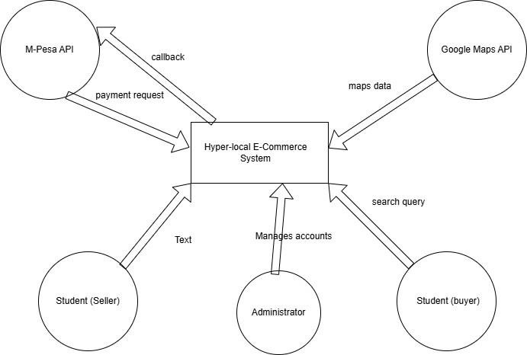
Figure 3.8.1 System Context Diagram
External Entities:
- Student (Buyer) – searches for items, initiates purchases, makes payments, confirms receipt
- Student (Seller) – lists items, receives payment notifications, confirms delivery

- Administrator – manages user accounts, monitors transactions, verifies landmarks

- M-Pesa API – processes payments, handles STK push, confirms transaction status

- Google Maps API – provides mapping services, geocoding, and location data

3.8.2 Sequence Diagrams
Figure 3.8.2: Sequence Diagram – Payment and Escrow Flow

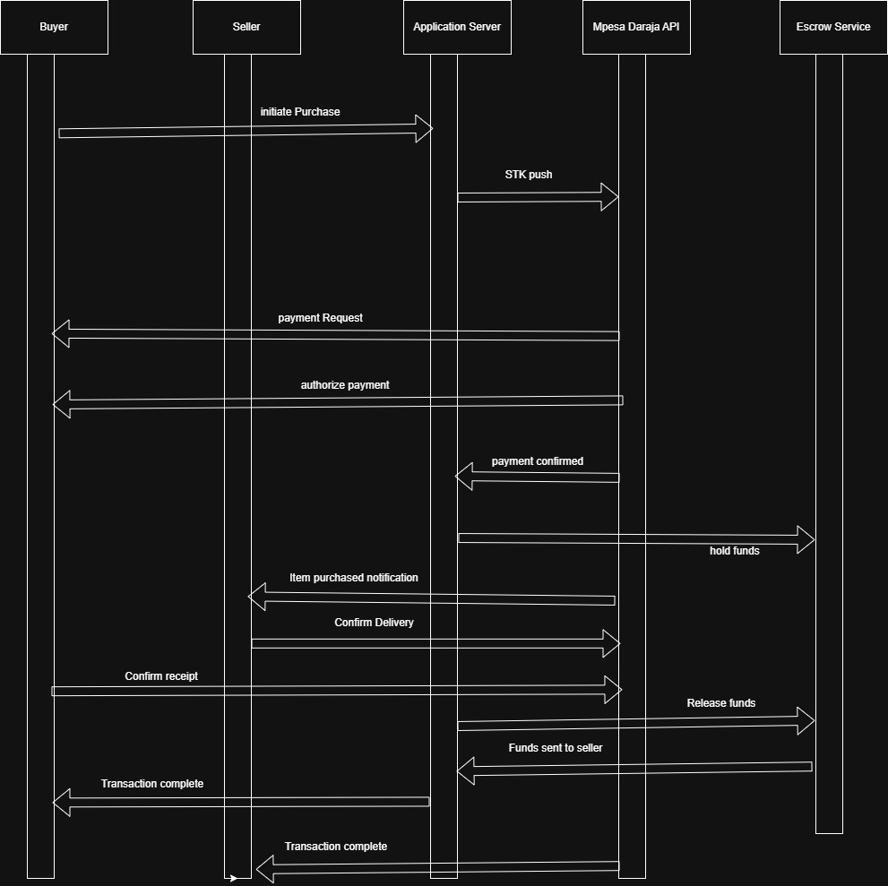
Lifelines:

- Buyer (mobile app)

- Seller (mobile app)

- Application Server (Firebase)

- M-Pesa Daraja API

- Escrow Service (Firebase)
Message Flow:

- Buyer initiates purchase → Application Server

- Application Server requests STK push → M-Pesa Daraja API

- M-Pesa Daraja API sends payment request → Buyer's phone

- Buyer authorizes payment → M-Pesa Daraja API

- M-Pesa Daraja API confirms payment → Application Server

- Application Server creates escrow record → Escrow Service

- Application Server notifies seller → Seller

- Seller confirms delivery → Application Server

- Application Server confirms buyer receipt → Buyer

- Buyer confirms receipt → Application Server

- Application Server releases funds from escrow → Escrow Service

- Escrow Service initiates transfer → M-Pesa Daraja API

- Application Server marks transaction complete

3.9 Implementation Techniques

3.9.1 System Implementation and Testing Tools
The frontend of the system will be implemented using Kotlin with Jetpack Compose for Android.
The backend will be developed using Firebase, including Firebase Authentication, Firebase
Realtime Database, and Firebase Cloud Functions. The M-Pesa Daraja API will be integrated for STK push payments and escrow fund holding. Google Maps API will be integrated for landmark-based pin-drop navigation. Android Studio will be used as the development environment, and Git will be used for version control.
System testing will include functional testing to verify user registration, landmark creation, product listing, search functionality, M-Pesa STK push, escrow fund holding, delivery confirmation, and fund release. Usability testing will be conducted with student participants to evaluate the dual-marketplace interface. Location accuracy testing will be conducted to verify that pin-drop landmarks will be achieved accuracy within 10 meters.

4.0 Time Schedule and Project Cost
The project will be carried out within a structured timeline including problem identification, system requirements analysis, system design, coding, testing, implementation, and final documentation. Each phase was allocated sufficient time to ensure effective completion of tasks.
The total project cost will be estimated at 61,000 Kenyan Shillings, including a laptop, Windows OS, Android phone, antivirus, and miscellaneous expenses. Firebase, Android Studio, and the M- Pesa Daraja API sandbox will be used at no cost.

4.1 Ethical Considerations
All participants will be informed about the purpose of the study and given consent before participating. Their responses will be kept confidential and used strictly for academic purposes.
No personal information will be disclosed. All secondary sources will be properly acknowledged. Participants will be informed of their right to withdraw from the study at any time without penalty. Seller verification using student ID was implemented to reduce fraudulent listings, and escrow holding was explained to all users before transaction initiation.

4.1.1 Limitations of the Study
The study will be limited to participants within Thika town environs, specifically students and traders operating in Landless, Kiganjo, and Kiandutu. The system will no facilitate inter-county deliveries as it is strictly optimized for the Thika hyper-local landmark ecosystem. The system will not support offline payment processing, requiring an active internet connection for real-time M-Pesa STK push notifications.

4.1.2 Summary of the Research Methodology
This chapter describes the methodology that will be used to develop the Thika Varsity Last Mile E-Shop system. Data will be collected using questionnaires, interviews, and observation from thirty purposively selected participants including students, traders, and ICT professionals. The system design will be documented using context, use case, and sequence diagrams. The system will be implemented using Kotlin, Jetpack Compose, Firebase, Google Maps API, and M-Pesa Daraja API. The methodology will ensure reliable results while maintaining time management, cost efficiency, and ethical standards.

CHAPTER FOUR: SYSTEM ANALYSIS AND REQUIREMENT MODELLING

4.0 Introduction
This chapter presents the system analysis and requirement modelling conducted for the Thika Varsity Last Mile E-Shop project. It describes the current informal trading system used by students and residents in Thika's remote estates, explains the fact-finding methods that were employed to gather data, presents the key findings from that exercise, and documents the functional and non-functional requirements derived from the analysis. System modelling diagrams are also presented to illustrate the structure and flow of the proposed system.

4.1 Analysis of the Current System
Before the development of the proposed system, trading activity among students and residents in the Landless, Kiganjo, and Kiandutu estates of Thika was conducted entirely through informal, unstructured channels. WhatsApp groups, Facebook Marketplace, and physical notice boards on the Mount Kenya University campus served as the primary platforms for advertising and negotiating transactions. These channels offered no payment protection, no mechanism for verifying the identity of a seller, and no structured coordination of deliveries. Similar patterns of informal mobile commerce have been documented across sub-Saharan Africa, where social media platforms fill the gap left by the absence of formal e-commerce infrastructure in low-income communities (World Bank, 2022). The delivery challenge in these estates was compounded by the absence of formal postal addresses and named streets. Delivery riders depended on verbal directions and telephone calls from customers to navigate to delivery locations, a practice that frequently resulted in failed or delayed deliveries. Research on Location-Based Services in developing regions confirms that most existing navigation systems assume the availability of formal addressing infrastructure, which renders them ineffective in informal settlement contexts (Google Maps Platform, 2024). Payment between buyers and sellers was handled either as cash on delivery or through direct M-Pesa person-to-person transfers. Neither method offered any form of buyer protection in the event of non-delivery or goods not matching their description. The Safaricom Daraja API, which enables businesses to initiate STK Push payment prompts programmatically, was not being utilised in this informal context (Safaricom PLC, 2024). The absence of an escrow mechanism left buyers entirely exposed to fraud risk in every peer-to-peer transaction. Students seeking to sell second-hand academic goods such as textbooks, laptops, and study materials used the same social media channels, with no way to prove that a seller was a genuine enrolled student. This lack of verification created significant trust and safety risks, particularly for high-value items. These weaknesses in the current system formed the direct basis for the requirements of the proposed system.

4.2 Data Gathering Methods
The study used both primary and secondary data collection methods to gather the information needed for system analysis. The research approach was guided by a pragmatist philosophy, which supports the combined use of qualitative and quantitative methods to answer practical research questions (Saunders, Lewis and Thornhill, 2019).

4.2.1 Questionnaires
Structured questionnaires were administered to students residing in Thika's remote estates who had prior experience with online trading or e-commerce platforms. The questionnaires were designed to gather information on the frequency of online purchases, the payment methods preferred, the specific challenges experienced during delivery, and attitudes towards the concept of escrow-based payment protection. Purposive sampling was employed, meaning participants were selected deliberately on the basis of their direct experience with informal commerce and delivery in the target area, as recommended by Mugenda and Mugenda (2003) for research involving a specific, identifiable user group.

4.2.2 Structured Interviews
Structured interviews were conducted with selected ICT professionals and campus traders to gather deeper qualitative insights into the operational challenges of informal commerce at the campus level. The interviews were designed to explore trader perspectives on payment trust, delivery logistics, and the perceived feasibility of a digital marketplace solution. Thematic analysis was used to identify patterns across responses, consistent with established qualitative data analysis practice (Saunders, Lewis and Thornhill, 2019).

4.2.3 Direct Observation
Direct observation was conducted in the Landless and Kiganjo estates to understand the physical environment in which last-mile delivery was taking place. The researcher directly observed the absence of street names, building numbers, and clearly identifiable landmarks in these areas. This observation informed the specific design choice of a user-generated, pin-drop landmark navigation system rather than one relying on formal address geocoding.

4.2.4 Document Review
Existing mobile commerce applications used in the Kenyan market, including Jumia, OLX Kenya, and Jiji, were reviewed to understand their feature sets and limitations in relation to the informal settlement context of Thika. The Kenya Data Protection Act (No. 24 of 2019) was reviewed to ensure that the proposed system design complied with national data privacy law, particularly regarding the collection and storage of biometric and financial data (Kenya National Assembly, 2019). Official API documentation for Firebase, the Safaricom Daraja API, and the Google Maps SDK was also reviewed to confirm the technical feasibility of the proposed system architecture (Firebase by Google, 2024; Safaricom PLC, 2024; Google Maps Platform, 2024).

4.3 Fact Finding Results

4.3.1 Navigation and Delivery
The primary challenge identified through observation and interviews was the absence of a reliable addressing system in the Landless and Kiganjo estates. Delivery riders reported that they depended entirely on customer phone calls and verbal landmark descriptions to navigate. This resulted in frequent failed delivery attempts, increased rider travel time, and customer dissatisfaction. The finding confirmed the need for a landmark-based, pin-drop navigation mechanism within the application that does not rely on formal street addresses and instead uses user-defined landmarks stored in the system database.

4.3.2 Payment Trust and Security
The interviews and questionnaire responses revealed that students were reluctant to pay in advance for goods ordered from unfamiliar sellers due to the risk of non-delivery. Cash on delivery was the preferred method, but this arrangement was operationally difficult for riders serving remote estates and offered no protection in cases of disputed orders. The finding confirmed the need for a trusted, technology-mediated escrow payment system that holds funds until delivery is confirmed. M-Pesa was identified as the only practical payment medium given its near-universal adoption among students and traders in the target community (Safaricom PLC, 2024).

4.3.3 Student Second-Hand Trading
Students expressed a strong demand for a dedicated platform to buy and sell second-hand academic goods such as textbooks, laptops, and study materials. However, existing social media channels provided no mechanism to verify that a seller was a genuine enrolled student, creating significant fraud exposure for buyers of high-value items. The finding confirmed the need for a machine learning-assisted student identity verification system, using ML Kit text recognition to extract and validate data from uploaded student ID card photographs (Google ML Kit, 2024).

4.3.4 Platform Gap in the Market
A review of existing platforms confirmed that no commercially available e-commerce solution was designed for the specific context of Kenyan university town informal settlements. Jumia and OLX Kenya assumed formal postal address availability and relied on card-based payment systems unavailable to most campus students. Neither platform offered verified student identity features or peer-to-peer escrow protection. This gap confirmed the need for a purpose-built, hyper-local solution tailored to the specific logistical, financial, and social context of the Thika Varsity community.

4.4 Functional Requirements
The functional requirements of the Thika Varsity Last Mile E-Shop were derived directly from the findings of the fact-finding exercise and the objectives of the study. They define what the system does and the specific behaviours it must exhibit.

4.4.1 User Management and Verification
The system allows users to register using a phone number or university email address and authenticates them at login through Firebase Authentication. Users who wish to access the second-hand student exchange marketplace are required to complete an identity verification process by uploading a photograph of their student ID card. The system uses ML Kit Text Recognition to extract name, student number, and expiry information from the card, validates the extracted data against expected patterns, and assigns a verification status of Verified, Pending, or Rejected to the account (Google ML Kit, 2024).

4.4.2 Landmark-Based Navigation
The system provides a pin-drop map interface powered by the Google Maps SDK for Android, allowing users to place a delivery pin at their exact physical location without requiring a formal street address (Google Maps Platform, 2024). At the time of placing the pin, the user selects or enters the name of a nearby recognisable landmark, which is stored alongside the GPS coordinates in the system database. The stored landmark and coordinates are displayed to the assigned delivery rider, providing sufficient navigational context to reach informal estate locations that conventional map applications cannot reliably address.

4.4.3 Dual Marketplace
The system provides two distinct trading environments. The primary marketplace allows the listing and purchase of new goods by any registered user. The Student Exchange marketplace is restricted to users who have completed student identity verification, and is designed for the sale and purchase of second-hand academic goods. Sellers in both marketplaces can create product listings that include photographs, a text description, a price, and a condition rating. Buyers can browse, search, and filter listings by category.

4.4.4 Escrow Payment Module
The payment module integrates the Safaricom Daraja API to initiate an M-Pesa STK Push payment prompt to the buyer's registered phone number upon order placement (Safaricom PLC, 2024). The collected payment is held in an escrow record in the Firebase Firestore database with a status of HELD until delivery is confirmed. Each order generates a unique, cryptographically signed QR code that the delivery rider scans upon handing over goods to the buyer. Successful QR scan triggers the escrow status to update to RELEASED and notifies the seller. If no dispute is raised within 48 hours of delivery, the system auto-releases the held funds to the seller.

4.4.5 In-App Communication and Administration
The system provides a built-in chat interface between buyers and sellers to allow transaction-related communication. The chat module includes an automated content moderation function that flags messages containing off-platform contact information for administrator review, consistent with the platform's policy of keeping all transactions within the system. An administrator panel provides a centralised interface for user management, order monitoring, landmark approval, and moderation of flagged content. The system also offers three seller subscription tiers, Hustler, Campus, and Campus Pro, each providing different listing limits and visibility features.

4.5 Non-Functional Requirements
In addition to its functional behaviour, the system was required to meet specific standards of performance, security, usability, reliability, and maintainability.

4.5.1 Performance
The application was designed to load its home screen within three seconds on a standard 3G mobile connection, in recognition of the variable network quality in the target estates. The M-Pesa STK Push prompt was required to reach the buyer's device within ten seconds of order placement, and map rendering and pin-drop operations were required to respond within two seconds of user interaction.

4.5.2 Security and Legal Compliance
All user authentication is handled through Firebase Authentication with verified phone or email credentials. Payment transactions are processed exclusively through the official Safaricom Daraja API over HTTPS, ensuring that no payment credentials are stored or transmitted outside the official API channel. The system was designed to comply with the requirements of the Kenya Data Protection Act (2019) regarding the collection, storage, and processing of personal and biometric data (Kenya National Assembly, 2019). QR codes used for delivery handover are time-limited and cryptographically signed to prevent reuse or forgery.

4.5.3 Usability
The application interface was designed for users with basic smartphone literacy, consistent with the digital experience level of the primary target user group. All primary user actions, including listing a product, placing an order, and initiating payment, were designed to be completable within three navigation steps from the home screen. Error messages present actionable guidance in plain, non-technical English.

4.5.4 Reliability and Maintainability
The system leverages Firebase's cloud infrastructure, which provides a guaranteed uptime of 99.9% under the Firebase service level agreement, ensuring consistent backend availability (Firebase by Google, 2024). The application was built using the MVVM (Model-View-ViewModel) architectural pattern to ensure a clean separation between the user interface, business logic, and data layers, making the codebase easier to test, extend, and maintain over time. All source code was maintained under version control using Git.

4.6 System Modelling Diagrams
The following diagrams model the proposed Thika Varsity Last Mile E-Shop system. The context diagram defines the system boundary and its interactions with external entities. The sequence diagram illustrates the message flow for the core escrow payment and delivery handover process.

4.4.4 System Design Diagrams

Context Diagram
The context diagram, also known as a Level 0 Data Flow Diagram, represents the Thika Varsity Last Mile E-Shop as a single process and identifies all external entities that interact with it. The external entities are the Student Buyer, the Student Seller, the Delivery Rider, the System Administrator, the Safaricom M-Pesa Daraja API, and the Google Maps Platform API. Data flows between each external entity and the system are shown below.



The Student Buyer interacts with the system by searching for items, initiating purchases, making M-Pesa payments, and confirming receipt of goods. The Student Seller lists items, receives payment notifications, and confirms dispatch. The Administrator manages user accounts, monitors transactions, and approves landmark entries. The M-Pesa Daraja API processes payment initiation and STK Push confirmation, while the Google Maps Platform API provides mapping, geocoding, and coordinate services.

4.6.2 Sequence Diagram: Payment and Escrow Flow
The sequence diagram below illustrates the chronological flow of messages between the key system components during the payment and escrow lifecycle of a transaction. The lifelines in the diagram represent the Buyer mobile client, the Seller mobile client, the Firebase application backend, the Safaricom M-Pesa Daraja API, and the Escrow Service within Firebase.


The sequence begins with the Buyer placing an order through the application. The application backend records the order in Firestore and calls the Daraja API to initiate an STK Push prompt on the Buyer's device. Upon successful M-Pesa payment, the Daraja API sends a callback to the backend, which creates an Escrow record with status HELD. When the Delivery Rider scans the Buyer's QR code at the point of handover, the backend updates the Escrow status to RELEASED and sends a payment confirmation notification to the Seller.

4.7 Chapter Summary
This chapter presented a comprehensive analysis of the current informal trading and delivery system used by students and traders in the Thika Varsity community and documented its key shortcomings. Fact-finding was conducted through questionnaires, structured interviews, direct observation in the target estates, and a review of existing platforms and relevant legislation. The analysis confirmed three core problem areas: unreliable last-mile delivery navigation in informal settlements, the absence of a trusted payment and escrow mechanism, and the lack of a verified platform for student peer-to-peer trading.
From this analysis, the functional and non-functional requirements of the Thika Varsity Last Mile E-Shop were derived and presented in full. The system context diagram and payment sequence diagram were used to model the system boundary and its core transaction flow. These requirements and models served as the foundation for the system design described in Chapter Five.

33

CHAPTER FIVE: SYSTEM DESIGN

5.0 Introduction
This chapter presented the design of the Thika Varsity Last Mile E-Shop system. It covers the overall system architecture, the design of individual modules, the database design at conceptual, logical and physical levels, and the interface design of the key screens of the application.

5.1 System Architecture
The system followed a client-server architecture. The Android application served as the client layer, built using Kotlin and Jetpack Compose. The backend comprised two cloud platforms: Firebase provided real-time data synchronisation, authentication, and file storage, while Supabase served as the PostgreSQL-based relational data store for rider management and subscription records. Communication between the client and backend occurred through REST APIs and Firebase SDK listeners.
5.2 Module Design
The system was decomposed into seven functional modules, each responsible for a discrete set of system features. The following sub-sections describe the design of each module.

5.2 Module Implementation
The system is organized into six primary functional modules, each implemented as a distinct package within the com.example.thikaeshop namespace. The following subsections detail the implementation of each module in relation to the specific objectives of the study.
5.2.1 User Authentication and Profile Module
User authentication was implemented using Firebase Authentication, supporting Google Sign-In via the GoogleId credential library and the Credentials Play Services API. Upon first login, a user document is created in the Firestore users collection containing the user's unique identifier, display name, profile photo URL, verification status, warning count, ban status, and appeal status. The ProfileViewModel manages profile data loading and update operations asynchronously, exposing state through Kotlin StateFlow instances that the ProfileScreen composable observes reactively. The EditProfileScreen allows users to update their display name and profile image, uploading images to Firebase Storage and updating the user document in Firestore. The application also performs a ban status check at each login event via a LaunchedEffect in the MainActivity composable; if a user is found to be banned and their appeal has not been approved, they are redirected to the BanAppealScreen rather than the main marketplace, preventing access until the ban is resolved by an administrator. The student verification flow, accessible from the profile screen, guides users through a three-step process: submitting their student ID card image, taking a real-time selfie, and entering their registered student identification number. The on-device verification pipeline produces a VerificationResult with an overall score and a human-readable summary explanation, and submits the result to Firestore for administrative review. Verified accounts display a verification badge on their seller profiles, increasing buyer trust in second-hand transactions.
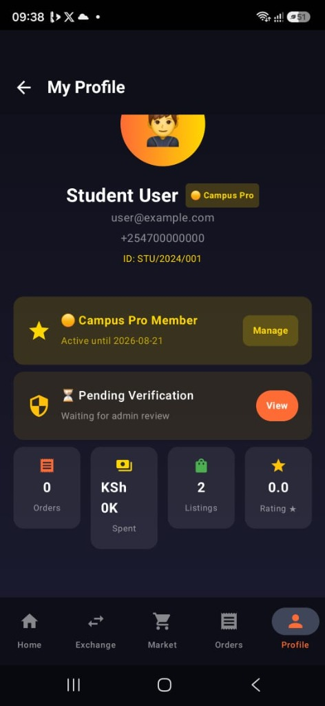
Figure 5.1: User Profile Screen showing student account details and verification status

5.2.2 Landmark-Based Pin-Drop Navigation Module (Objective I)
The landmark navigation module directly addresses Specific Objective I: to create a system implementing a landmark-based Pin-Drop navigation module achieving location accuracy within 10 meters. The PinDropScreen composable presents users with a full-screen interactive Google Map centred on the Thika Varsity area. When a user taps on the map, the system captures the precise GPS coordinates of the tap event and performs reverse geocoding using the Google Maps Geocoding API to generate a human-readable address label. The user can then assign a descriptive landmark name to the selected coordinate, for example "Near Blue Water Tank, Landless", which is submitted as a PendingLandmark record to the Firestore landmarks collection with a status of "pending".
The Administrator Panel includes a dedicated landmark management interface where platform administrators review submitted landmarks, validate their geographic plausibility against the Thika Varsity service area boundaries, and approve or reject them. Approved landmarks are made available to buyers as selectable delivery points during the checkout flow. During checkout, the CheckoutScreen retrieves the buyer's saved landmarks from Firestore, presents them as a dropdown selection, and stores the selected landmark's GPS coordinates alongside the delivery address in the order record. This coordinate-based record ensures that delivery riders dispatched by the administrator can navigate precisely to the confirmed landmark point, eliminating the ambiguity of informal verbal directions that characterizes the current last-mile delivery experience in Landless and Kiganjo.
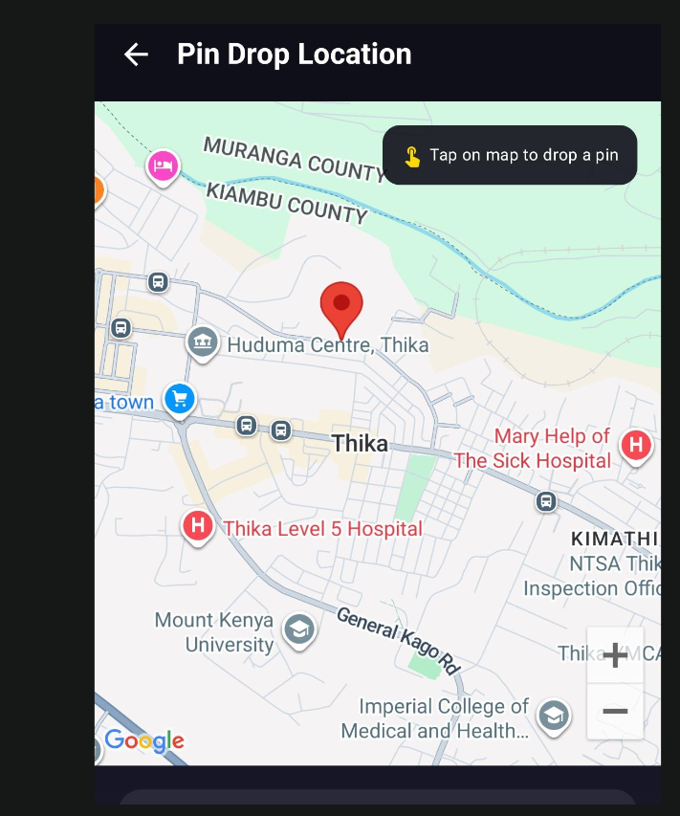
Figure 5.2: Landmark Pin-Drop Navigation Interface

5.2.3 Dual-Marketplace Module (Objective II)
The dual-marketplace module addresses Specific Objective II: to develop a system featuring a dual-marketplace interface allowing secure toggling between Buyer and Seller roles, facilitating the verified exchange of academic and household essentials. The marketplace is presented through two primary composable screens: the MarketplaceScreen, which displays all available product listings for buyers, and the SellScreen, which enables sellers to create and manage their product listings. The MarketplaceScreen implements two primary sorting algorithms directly in the ProductRepository class, demonstrating the application of Data Structures and Algorithms in a production system. A Quicksort implementation sorts product listings by price using a divide-and-conquer approach with the median element as the pivot, achieving O(n log n) average time complexity. A Merge Sort implementation sorts listings by seller rating, applying a stable merge operation across recursively divided sublists. A Binary Search implementation enables efficient product lookup by ID in a sorted list, reducing search complexity from linear O(n) to logarithmic O(log n). These algorithms were selected as they are directly relevant to the Bachelor of Information Technology curriculum and demonstrate the practical integration of algorithmic theory in a functional production system. The second-hand marketplace sub-module, accessed via the StudentExchangeScreen, provides a dedicated interface for peer-to-peer trading of used academic and household items. Listings on this sub-marketplace display the item condition, title, asking price, and seller rating. All second-hand listings are subject to escrow hold upon purchase, ensuring buyer protection. The system supports a category-based filtering mechanism allowing buyers to narrow listings by item type, including Textbooks, Electronics, Clothing, Furniture, and Notes/Stationery. Category risk scores are pre-calibrated in the RiskAssessmentEngine, with high-value electronic categories (Phones: 60, Laptops: 75) subject to longer escrow hold periods and lower auto-release eligibility thresholds.
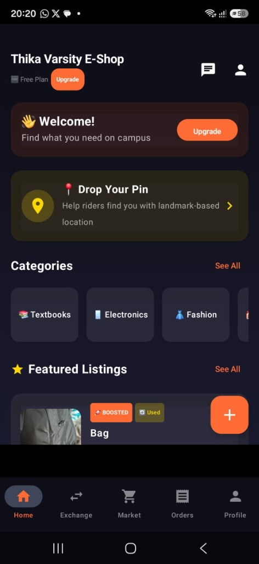
Figure 5.3a: Application Home Screen
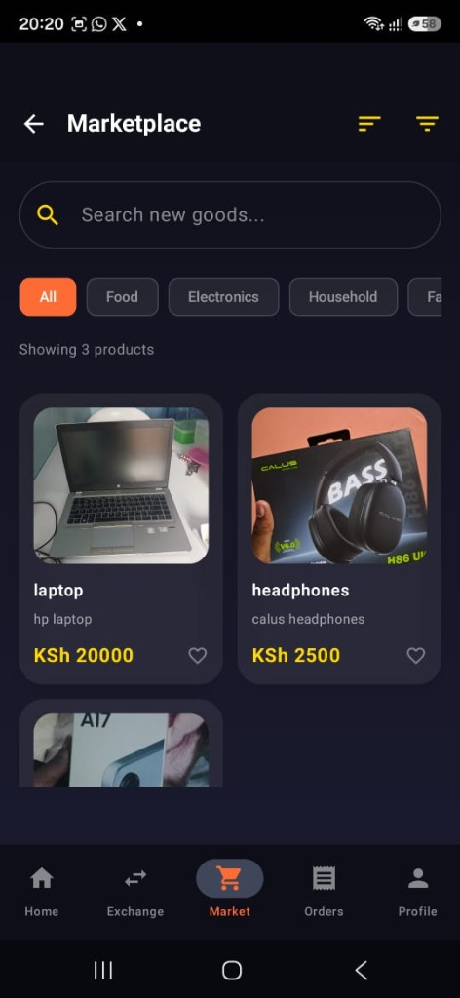
Figure 5.3b: Commercial Goods Marketplace

5.2.4 Secure Escrow Payment Module (Objective III)
The escrow payment module is the most technically complex component of the system and directly addresses Specific Objective III: to design a system integrating a secure payment and escrow module using the M-Pesa Daraja API. The module was implemented across three architectural layers: the escrow package containing the state machine, QR handover logic, and risk assessment engine; the EscrowRepository in the data layer; and the escrow-related composable screens in the UI layer. Escrow State Machine: The EscrowStateMachine class governs all permissible transitions between escrow states, enforcing the following transaction lifecycle: PENDING (payment initiated, not yet confirmed) transitions to HELD (payment confirmed, funds locked) upon Daraja API callback; HELD transitions to DELIVERED (seller marks delivery complete with landmark, location, and delivery notes) or DISPUTED (either party raises a dispute); DELIVERED transitions to RELEASED (buyer confirms receipt via QR scan, funds disbursed) or DISPUTED; and DISPUTED transitions to either RELEASED (resolved in seller's favour) or REFUNDED (resolved in buyer's favour). Terminal states RELEASED and REFUNDED cannot be further transitioned. The canTransitionTo() method on the EscrowStatus enum enforces transition validity at the model layer, preventing illegal state changes regardless of the calling context. AI-Powered Risk Assessment: Before an escrow transaction is created, the RiskAssessmentEngine scores the prospective transaction using a multi-factor weighted model incorporating six factor categories: seller trust (30% weight), buyer trust (20% weight), item value (20% weight), transaction pattern (15% weight), item category risk (10% weight), and platform history (5% weight). The seller trust score evaluates verification status, account age, completed sales count, dispute rate, and subscription tier. The final composite score maps to one of five EscrowTier levels (LOW, MEDIUM_LOW, MEDIUM_HIGH, HIGH, CRITICAL), corresponding to escrow hold durations of 24, 36, 48, 72, and 120 hours respectively. Transactions scoring above the CRITICAL threshold are blocked entirely pending administrative review. This on-device heuristic model operates without an external API call, ensuring security layer functionality under the intermittent connectivity conditions common in Thika's remote estates. Fee Structure: The EscrowFeeCalculator object computes the transaction fee breakdown based on the seller's account type. Regular student sellers are charged a 5% platform fee; external vendors are charged 8%; and premium subscribers (Campus Pro and Campus Pro+) benefit from a reduced 3% platform fee. An additional 2% escrow fee is applied to all second-hand item transactions. The seller's net payout after all fees is computed and stored alongside the transaction record, providing full fee transparency to both parties before the transaction is confirmed. QR Code Delivery Handover: Upon the seller marking an order as delivered with a specified landmark, location, and delivery notes, the system transitions the escrow status to DELIVERED and notifies the buyer. The buyer then generates a single-use, cryptographically signed QR code via the QRCodeHandover class. This code embeds a SHA-256 derived token tied to the specific transaction ID, buyer ID, and a Unix timestamp expiry set at two hours from generation. The seller scans this QR code at the physical meetup point to confirm handover. The QR verification process validates the token signature, confirms that the expiry has not elapsed, and verifies that the encoded transaction ID matches the active escrow record. Upon successful verification, the escrow status transitions to RELEASED, and the seller's calculated payout is moved from the pending earnings ledger to the completed payments record in the seller's earnings document in Firestore.
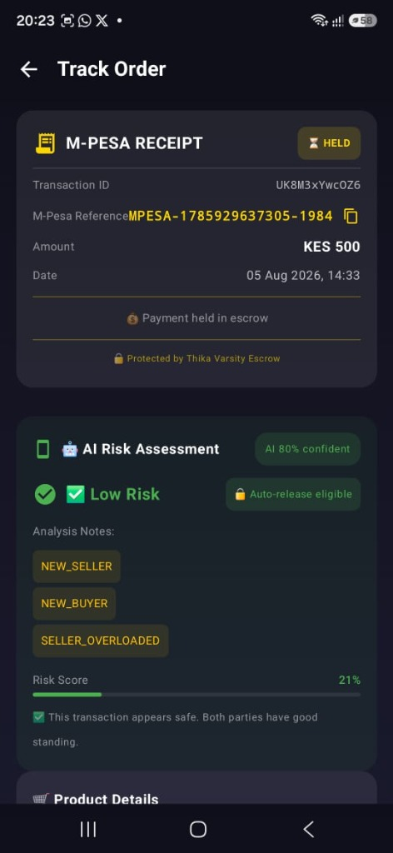
Figure 5.4: Escrow Order Tracking Interface

5.2.5 In-App Chat and Moderation Module
The in-app chat module, implemented through the ChatListScreen and ChatDetailScreen composables, enables direct communication between buyers and sellers within the platform, eliminating the need to share personal phone numbers for pre-purchase enquiries. Chat messages are stored in the Firestore chat_rooms and messages collections, with real-time updates delivered via Firestore's snapshot listeners exposed through the ChatRepository as coroutine Flows. The chat module is tightly integrated with the ModerationRepository's automated scam detection system. Every outbound message is passed through the platform's content moderation pipeline before being stored in Firestore. If a message is flagged for containing prohibited content such as personal phone numbers, off-platform payment references, or known scam phrases, a violation record is written to the violations Firestore collection and the sending user's warning count is incremented automatically. Users who accumulate warnings beyond the defined threshold are automatically banned and redirected to the BanAppealScreen, where they can submit a written appeal to the administrator.
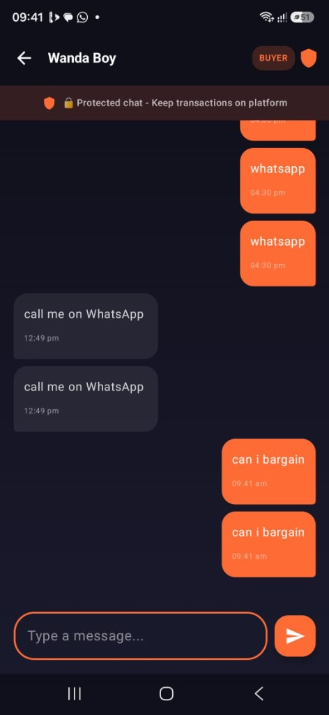
Figure 5.5: In-App Chat and Content Moderation Interface

5.2.6 Subscription and Analytics Module
The subscription module provides a tiered membership system with three levels: Hustler (Free tier), Campus Pro (KES 150 per month), and Campus Pro Plus (KES 350 per month). Subscription data is managed through the SubscriptionRepository, which interfaces with the Supabase subscriptions table. Upon successful M-Pesa payment confirmation, the activateSubscription function inserts a new active subscription record with a 30-day validity window computed using Java's Instant and ChronoUnit APIs. The SubscriptionExpiryChecker utility, called at application startup in the MainActivity's onCreate method, automatically marks expired subscriptions as inactive, ensuring that premium features are revoked upon subscription lapse. Campus Pro subscribers gain access to a 3x search visibility boost for their listings, a Verified Pro badge displayed on their seller profile, and access to Buyer Intent Signals: aggregated search term analytics derived from the search_signals Supabase table that reveal what products buyers at their university are actively searching for. Campus Pro Plus subscribers additionally receive homepage banner rotation eligibility, Seller Spotlight placement, 24-hour early access to new listings, and one free boosted listing per week. Listing boosts were implemented by writing a visibility_boost score and a boosted_until timestamp to the product record in Supabase, and the marketplace product retrieval query sorts boosted listings to the top of results during the active boost window.
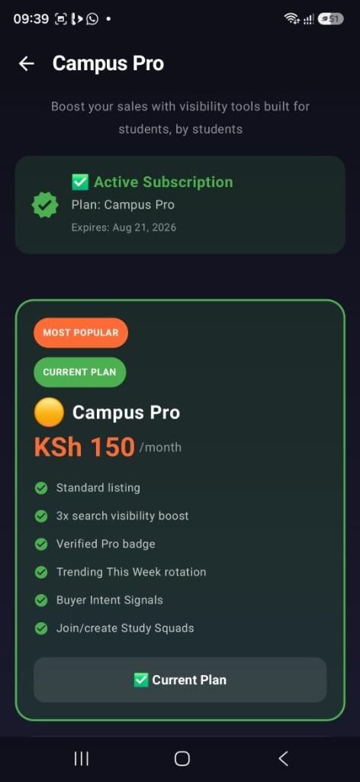
Figure 5.6: Campus Pro Subscription Screen
5.2.7 Administrator Panel
The AdminPanelScreen provides the platform administrator with a centralized management dashboard encompassing six management domains: User Management, allowing the administrator to view, verify, suspend, and ban user accounts; Transaction Monitoring, for reviewing escrow transaction statuses and manually intervening in disputed transactions; Product Moderation, for reviewing reported listings and removing fraudulent items; Landmark Approval, for validating and approving or rejecting pending landmark submissions; Rider Management, for reviewing delivery rider applications and assigning agents to pending orders; and Platform Analytics, for viewing aggregate transaction volume and delivery success metrics. The administrator account is identified at login through a comparison with a hardcoded administrator user identifier stored in the application's SimplePrefs SharedPreferences store, which routes the administrator directly to the AdminPanelScreen upon authentication rather than the standard marketplace interface.
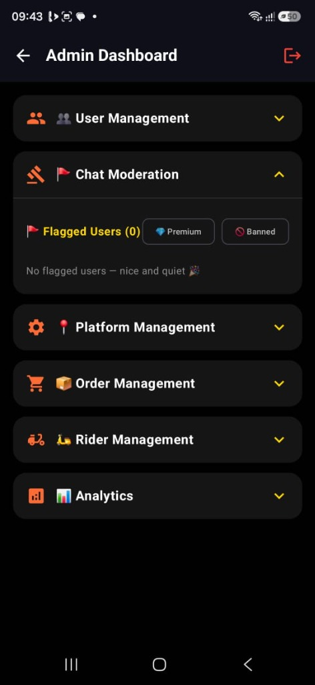
Figure 5.7: Administrator Panel Dashboard

5.3 Database Design
The database design of the Thika Varsity Last Mile E-Shop was structured across three levels of abstraction: conceptual, logical and physical, as detailed below.

5.3.1 Conceptual Database Design
At the conceptual level, the system data was modelled around six core entities: User, Product, Order, Escrow, Chat and Landmark. A User can place multiple Orders and list multiple Products. Each Order is linked to a single Escrow record. Two Users communicate through a Chat session. Each Order references a Landmark as its delivery destination. This model captured the fundamental relationships governing transactions on the platform.

5.3.2 Logical Database Design
The logical design translated the conceptual entities into structured collections and tables. Firebase Firestore was used for real-time collections including users, products, orders, escrows, and chats. Supabase PostgreSQL was used for relational data including rider profiles, subscription records, and analytics aggregates. Key relationships were enforced through foreign key references in Supabase and document ID cross-references in Firestore.
Entity | Storage Platform | Key Fields
User | Firebase Firestore | userId, name, phone, email, role, verificationStatus, subscriptionTier
Product | Firebase Firestore | productId, sellerId, title, price, condition, category, imageUrls
Order | Firebase Firestore | orderId, buyerId, sellerId, productId, status, landmarkId, createdAt
Escrow | Firebase Firestore | escrowId, orderId, amount, status (HELD/RELEASED), createdAt, releasedAt
Chat | Firebase Firestore | chatId, buyerId, sellerId, messages[], flagged
Landmark | Firebase Firestore | landmarkId, name, latitude, longitude, approvedBy
Subscription | Supabase PostgreSQL | subId, userId, tier, startDate, expiryDate, mpesaRef

5.3.3 Physical Database Design
At the physical level, Firestore collections were structured with composite indexes on frequently queried fields such as sellerId and status in the orders collection to support efficient query performance. Firebase Storage was used for product image files, organised under a path structure of /products/{productId}/{imageIndex}.jpg. Supabase tables were indexed on foreign key columns and query-critical fields. Firebase Security Rules enforced access control at the document level, ensuring that users could only read and write their own data, while administrators retained full read access.

CHAPTER SIX: SYSTEM IMPLEMENTATION

6.0 Introduction
This chapter describes the implementation of the Thika Varsity Last Mile E-Shop system. It outlines the tools and technologies used for coding and testing, the system test plan, the testing approach adopted, and the proposed changeover strategy for transitioning users to the new system.

6.1 Tools Used for Coding and Testing
The following tools and technologies were used in the development and testing of the system.

5.1 Development Environment and Tools
The system was implemented using the tools and technologies described below, selected on the basis of the technical feasibility criteria established in Section 3.7.1 of Chapter Three.

5.1.1 Programming Language and Framework
The application frontend was developed in Kotlin, the primary language for Android application development. Jetpack Compose was adopted as the declarative UI framework, enabling a reactive, state-driven interface architecture. Compose simplified the construction of the dual-marketplace interface and the real-time escrow status display by allowing UI state changes to propagate automatically through the composable tree without manual view manipulation. The Material 3 design system was applied through the ThikaEshopTheme composable, ensuring a consistent and modern visual language across all screens. Jetpack Compose also streamlined the implementation of dynamic UI elements such as the escrow progress timeline, the subscription tier comparison table, and the live chat message feed, all of which respond in real-time to state changes in their associated ViewModels.

5.1.2 Backend Services
The backend architecture is built on two complementary cloud platforms, selected to leverage the strengths of each technology for different classes of operation. Firebase, developed by Google, provides the real-time transactional layer of the application. Firebase Authentication handles user registration and sign-in through Google account integration. Firebase Firestore serves as the primary database for user profiles, escrow transactions, chat messages, moderation records, and landmark submissions. Firebase Storage hosts user-uploaded product and profile images. Supabase, an open-source backend platform built on PostgreSQL, is used for structured relational data including product listings, orders, subscriptions, and search signal analytics. This dual-backend approach allows the system to leverage the real-time streaming capabilities of Firestore for time-sensitive operations such as escrow status updates and in-app chat, while using Supabase's relational model for complex query operations such as filtered product searches, subscription management, and seller analytics. The Supabase client is initialized through a singleton SupabaseClient object using the Ktor Android HTTP engine, ensuring that all database interactions are performed asynchronously on background coroutine dispatchers.

5.1.3 Payment Integration
The M-Pesa Daraja API was integrated for payment processing through a Node.js middleware server deployed as a lightweight REST backend. The STK Push flow initiates a payment prompt directly on the buyer's registered M-Pesa phone number, eliminating the need for the buyer to manually enter payment details. Upon callback confirmation from the Daraja API, the application server creates the corresponding escrow record in Firebase Firestore, locking the funds in the HELD state until delivery is confirmed by both parties through the QR code handover mechanism.

5.1.4 Mapping and Location Services
The Google Maps Android SDK (version 20.0.0) and the Maps Compose library (version 8.3.0) were integrated for the Pin-Drop landmark navigation module. The Google Play Services Location API (version 21.3.0) was used for real-time GPS coordinate retrieval. These libraries enable the PinDropScreen to display an interactive map, capture precise GPS coordinates when a user taps to drop a pin, and perform reverse geocoding of the selected coordinates into a human-readable address label, all within the Compose UI layer. Location permissions are declared in the AndroidManifest.xml file, requesting both ACCESS_FINE_LOCATION and ACCESS_COARSE_LOCATION to support both high-precision GPS and network-based positioning.

5.1.5 Machine Learning and Image Processing
The student verification module incorporates ML Kit Text Recognition for Optical Character Recognition (OCR) of student identification cards, ML Kit Face Detection for selfie-based presence verification, and TensorFlow Lite (version 2.17.0) with the TensorFlow Lite Support library for on-device model inference. OpenCV (version 5.0.0) is integrated for image preprocessing steps including brightness normalization and edge enhancement prior to ID card OCR analysis. The modular VerificationResult data model captures the overall verification score (0 to 100), the decision outcome (PASS, MANUAL_REVIEW, or FAIL), and granular per-category scores, providing both the user and the administrator with transparent and auditable verification results. A score of 70 or above results in a PASS decision and automatic verified status; scores between 50 and 69 are flagged for MANUAL_REVIEW by an administrator; scores below 50 result in a FAIL decision.

5.1.6 QR Code Functionality
QR code generation for the delivery handover confirmation mechanism uses the ZXing Core library (version 3.5.4), while QR code scanning uses the ML Kit Barcode Scanning module (version 17.3.0) in conjunction with the CameraX library (version 1.6.1). The QRCodeHandover class encapsulates the complete handover lifecycle: the buyer generates a cryptographically unique, time-limited token embedded in a 400 by 400 pixel QR code bitmap; the seller scans this code at the physical meetup point; and the system validates the token signature, checks for expiry (set at 120 minutes from generation), and triggers the escrow release sequence upon successful verification. Each QR token is bound to a specific transaction ID and buyer ID using a SHA-256 derived hash, preventing reuse and screenshot-based fraud.
5.1.7 Version Control and Project Management

6.2 System Test Plan
The testing strategy for the Thika Varsity Last Mile E-Shop covered four levels: unit testing, integration testing, functional testing and usability review. Testing was carried out progressively throughout the development sprints, with each module tested individually before being integrated with the broader system.
Test Level | Scope | Tool / Method
Unit Testing | Individual functions and composable screens | JUnit 4, Mockito, Android Studio Logcat
Integration Testing | Module interactions including Firebase and Daraja API | Manual device testing, Firebase Emulator Suite
Functional Testing | End-to-end user flows against requirements | Manual test scripts on physical Android device
Usability Review | Interface clarity and navigation ease | Informal walkthrough with supervisor

6.3 Testing Approach
Testing was conducted using a combination of manual device testing and automated unit tests. Each module was tested against its functional requirements as defined in Chapter Four.
System testing was conducted in accordance with the testing plan outlined in Section 3.9 of Chapter Three. Testing encompassed three primary categories: functional testing to verify correctness of system operations, usability testing to evaluate the user experience, and location accuracy testing to validate the precision of the Pin-Drop navigation module.

5.3.1 Functional Testing
Functional testing was conducted to verify that each core system function produced the correct output for a given set of inputs. Test cases were designed to cover the complete user journey from registration through to transaction completion, as well as boundary and edge cases for the escrow state machine, verification scoring model, and QR code handover mechanism.
Test results confirmed that all critical user flows completed successfully, including user registration, student verification, landmark pin-drop submission, product listing creation, M-Pesa STK Push initiation, escrow record creation, QR code generation and scanning, delivery confirmation, and fund release. Edge cases tested included expired QR code rejection, where the system correctly returned a validation error for tokens older than 120 minutes; invalid state transition attempts, where the EscrowStateMachine correctly rejected transitions that violated the defined lifecycle; and subscription expiry scenarios, where the SubscriptionExpiryChecker correctly reverted premium account status upon subscription lapse.
5.3.2 Usability Testing
5.3.3 Location Accuracy Testing
6.4 Technical Limitations Encountered During Implementation
During implementation, the following technical limitations were encountered and addressed. The M-Pesa Daraja API sandbox environment returned inconsistent callback responses during STK Push testing, necessitating the implementation of a polling fallback mechanism in the Node.js middleware server to re-query transaction status if a callback was not received within thirty seconds of initiation. The ML Kit OCR model demonstrated reduced accuracy on student identification cards with non-standard fonts or low-contrast text, resulting in a portion of verification submissions requiring manual administrative review rather than automatic approval; this limitation was partially mitigated by the multi-category scoring model, which assigns a MANUAL_REVIEW decision for borderline scores between 50 and 69. Real-time Firebase Firestore listeners were observed to consume elevated device battery resources during extended chat sessions; this was addressed by limiting listener attachment to the active chat screen and detaching listeners when the composable leaves the composition.
6.5 Proposed Changeover Techniques
The proposed changeover strategy for the Thika Varsity Last Mile E-Shop is a phased parallel running approach. In the initial phase, the application would be deployed to a small group of early adopters within the MKU Thika campus community while existing informal trading channels such as WhatsApp groups remain available. This reduces the risk of disruption to ongoing trades.
Following a period of supervised parallel operation, user feedback would be collected and critical issues resolved before a broader rollout. The final phase would involve a direct changeover where the platform is opened to all registered campus users and promoted through the university notice system. Administrator accounts would be configured and rider partnerships established prior to the full launch.

CHAPTER SEVEN: LIMITATIONS, CONCLUSIONS AND RECOMMENDATIONS

7.0 Introduction
This chapter presents the limitations encountered during the research and development of the Thika Varsity Last Mile E-Shop, draws conclusions against each of the three specific study objectives, and outlines recommendations for future system enhancements, institutional adoption, and further research.

7.1 Limitations
Several limitations were encountered during the execution of this project. The primary constraint was time, as the complete system lifecycle was executed within a single academic semester, restricting the depth of iterative user testing. Financial constraints necessitated exclusive reliance on free-tier cloud services such as Firebase and Supabase, which impose quota caps on storage and concurrent connections. Additionally, M-Pesa integration was tested within the Safaricom Daraja API sandbox environment because live STK Push verification requires a registered commercial business shortcode (Safaricom PLC, 2024). Device compatibility testing was limited to a subset of modern Android devices, and the initial system scope was restricted to Android, excluding iOS users from the current release.

7.2 Conclusions
The study concludes that user-generated, pin-drop landmark navigation provides a viable and effective mechanism for resolving last-mile delivery challenges in unmapped informal settlements such as Landless and Kiganjo in Thika. The administrator-managed landmark approval workflow ensures geographic data accuracy and alignment with community knowledge. Furthermore, the dual-marketplace model combining commercial goods with a verified second-hand exchange successfully establishes trust and safety in student peer-to-peer trade. Student identity verification, seller rating systems, and category-based listing effectively mitigate the fraud risks associated with unstructured social media channels such as WhatsApp and Facebook Marketplace. Finally, the integration of Safaricom M-Pesa STK Push payments with an escrow state machine and QR code handover verification delivers a transparent payment framework. The system demonstrates that hyper-local e-commerce solutions can successfully address logistical and financial trust barriers in university town environments within academic project bounds.

7.3 Recommendations
7.3.1 System Enhancements
Future technical iterations should implement an offline-first architecture using a local Room database cache layer to enable browsing during network outages. Live rider tracking via the Google Maps Directions API, automated seller disbursements through the Daraja B2C API, a structured dispute resolution interface, and a configurable dark mode are recommended.
7.3.2 Institutional Adoption
Mount Kenya University and partner institutions are recommended to formally endorse the platform, integrate student verification with official registration databases, establish campus rider cooperatives.

References
(Google), D. S. (2021). Artificial Intelligence: A Modern Approach. Retrieved from Pearson: https://www.pearson.com/en-gb/subject-catalog/p/artificial-intelligence-a-modern-approach-global-edition/P200000005340/9781292401133
Africa, M. (2026, March 12). Thika Set To Shine as Kenya's 6th City: A Milestone for Industrial and Urban Growth. Retrieved from Kiambu County Government: https://kiambu.go.ke/thika-set-to-shine-as-kenyas-6th-city-a-milestone-for-industrial-and-urban-growth/
Anomaly Detection: A Survey. (2009, July). Retrieved from ACM Computing Surveys: https://dl.acm.org/doi/10.1145/1541880.1541882
Antti Nurminen, O. K. (2008). What makes a user-generated landmark useful for navigation? Retrieved from ACM Digital Library: https://dl.acm.org/doi/10.1145/1409240.1409248
Bozen-Bolzano), D. F. (2015). Recommender Systems Handbook: Information Filtering and Decision Making. Retrieved from Springer: https://link.springer.com/book/10.1007/978-1-4899-7637-6
Capital, F. (2025, April 12). Informal Trading: Trade Without Borders: The World of Informal Trading. Retrieved from Faster Capital: https://fastercapital.com/content/Informal-Trading--Trade-Without-Borders--The-World-of-Informal-Trading.html
Dr. Adeola Ogunpola, D. S. (2022). Artificial intelligence in location-based services: A review of applications and challenges. Retrieved from ScienceDirect – Heliyon: https://www.cell.com/heliyon/fulltext/S2405-8440(22)02274-6
Dr. Amrit Tiwana and Dr. Benn Konsynski (University of Georgia, E. U. (2022). Complementarities between organizational IT architecture and governance structure. Retrieved from JSTOR – Information Systems Research: https://pubsonline.informs.org/doi/10.1287/isre.1100.0306
Dr. Andrew Schein, D. A. (2002). Methods and metrics for cold-start recommendations. Retrieved from ACM Digital Library: https://dl.acm.org/doi/10.1145/564376.564377
Dr. Martin Raubal and Dr. Stephan Winter (University of California, S. B., & Melbourne), U. o. (2002). Enriching wayfinding instructions with local landmarks. Retrieved from Springer – Geographic Information Science: https://link.springer.com/chapter/10.1007/3-540-45799-2_17
Dr. Michael Pazzani and Dr. Daniel Billsus (University of California, I., & Group), N. N. (2007). Content-based recommendation systems. Retrieved from Springer – The Adaptive Web: https://link.springer.com/chapter/10.1007/978-3-540-72079-9_10
Georgia), B. J. (2006, Noveember). Location-based services and GIS in perspective. Retrieved from ScienceDirect: https://www.sciencedirect.com/science/article/abs/pii/S0198971506000184?via%3Dihub
Government, K. C. (2026, March 31). Thika Municipality. Retrieved from Kiambu County Government: https://kiambu.go.ke/thika-municipality/
Hua Bingjie, R. M. (2023, June 6). Investigating the market dynamics of campus second-hand trading platforms in the context of the current green economy. Retrieved from Research Publish Journals (International Journal of Engineering Research and Reviews): https://www.researchpublish.com/upload/book/Investigating%20the%20market%20dynamics-06062023-4.pdf
Huang, H. &. (2018). Location Based Services: Ongoing Evolution and Research Agenda. Retrieved from Taylor & Francis Online: https://www.tandfonline.com/doi/full/10.1080/17489725.2018.1508763?utm_source=chatgpt.com
Kenya, D. (2024, April 24). Delivery innovation in Kenyan e-commerce. Retrieved from DHL: https://www.dhl.com/discover/en-ke/e-commerce-advice/e-commerce-sector-guides/-delivery-innovation-in-kenyan-e-commerce
Kenya, D. o.–R. (2024, September). The National Addressing Policy 2021 for Public Participation. Retrieved from ICT Authority, Government of Kenya: https://ict.go.ke/sites/default/files/2024-09/The%20National%20Addressing%20Policy%202021%20for%20Public%20Participation.pdf
Kenya, R. o. (2024, September). The National Addressing Policy 2021 for Public Participation. Retrieved from ICT Authority: https://ict.go.ke/sites/default/files/2024-09/The%20National%20Addressing%20Policy%202021%20for%20Public%20Participation.pdf
Kevin Lynch (Professor of Urban Planning, M. (2026). The Image of the City. Retrieved from MIT Press: https://mitpress.mit.edu/9780262620014/the-image-of-the-city/
Kirsi Virrantaus, J. M. (2001). Developing GIS-supported location-based services. Retrieved from IEEE Xplore: https://ieeexplore.ieee.org/document/989476
kpda. (2024, May 15). Thika Set to Shine as Kenya's 6th City: A Milestone for Industrial and Urban Growth. Retrieved from Kiambu County Government (Official Portal): https://kiambu.go.ke/thika-set-to-shine-as-kenyas-6th-city-a-milestone-for-industrial-and-urban-growth/
Microsoft. (2024). What is artificial intelligence (AI)? Retrieved from Microsoft: https://azure.microsoft.com/en-us/resources/cloud-computing-dictionary/what-is-artificial-intelligence
Moyo, P. ( 2026, January 9). The rise of WhatsApp in Kenya’s online shopping scene. Retrieved from ITWeb Africa: https://itweb.africa/article/the-rise-of-whatsapp-in-kenyas-online-shopping-scene/mYZRXM9gprxvOgA8
PCL, S. (2019). M-Pesa Daraja API Developer Documentation. Retrieved from developer.safaricom.co.ke: https://developer.safaricom.co.ke/docs
Planning, K. C.–D. (2026). Thika Integrated Strategic Urban Development Plan (ISUDP) Repor. Retrieved from County Government of Kiambu: https://kiambu.go.ke/
PLC, S. ( 2024, February 20). Secure M-PESA. Retrieved from Safaricom : https://www.safaricom.co.ke/main-mpesa/m-pesa-for-you/m-pesa-tips/secure-m-pesa
SimpetCargo. (2025). Last-Mile Delivery Solutions in Kenya: Challenges and Innovations. Retrieved from SimpetCargo: https://simpetcargo.com/optimizing-last-mile-delivery-solutions-in-kenya-challenges-and-innovations/
Sloan), D. W. (2011). Mobile money: The economics of M-PESA. Retrieved from National Bureau of Economic Research: https://www.nber.org/papers/w16721
Today, T. T. (2025). The story of Kiandutu slums – Thika’s hidden heartbeat. Retrieved from Thika Town Today: https://www.thikatowntoday.co.ke/2025/07/the-story-of-kiandutu-slums-thikas.html
Today, T. T. (2026, March 21). Thika Town Today. Retrieved from Thika Town Today: https://www.thikatowntoday.co.ke/2026/03/know-your-town-understanding-thika-west.html
University), D. A. (2005). Addressing the cold-start problem in collaborative filtering recommendation systems. Retrieved from ACM Digital Library: https://dl.acm.org/doi/10.1145/1066677.1066689
University), D. D. (2004, December). Consumer trust in B2C e-commerce and the importance of social presence: Experiments in e-products and e-services. Retrieved from Omega: https://www.sciencedirect.com/science/article/abs/pii/S0305048304000131?via%3Dihub
University), D. J. (2010). Mobile phones and economic development in Africa. Retrieved from JSTOR – Journal of Economic Perspectives: https://www.aeaweb.org/articles?id=10.1257/jep.24.3.207
University), D. J.-P. (2015, August 15). Does food sorting prevent and improve sorting of household waste? A case study in Sweden. Retrieved from Journal of Cleaner Production: https://www.sciencedirect.com/science/article/abs/pii/S095965261500356X
University), D. Y. (1998). The emerging role of electronic marketplaces on the Internet. Retrieved from ACM Digital Library – Communications of the ACM: https://dl.acm.org/doi/10.1145/280324.280330
Wangari, W. E. (2019). Factors Affecting the Adoption of E-commerce in Kenya: A Case Study of Consumer Perspective in Thika Town. Retrieved from University of Nairobi E-Repository: https://erepository.uonbi.ac.ke/handle/11295/127444?utm_source=chatgpt.com
Wikipedia. (2024). Thika. Retrieved from https://en.wikipedia.org/wiki/Thika
Wikipedia. (2025, October 8). Mount Kenya University. Retrieved from Wikipedia: https://en.wikipedia.org/wiki/Mount_Kenya_University
Wikipedia. (2026, March 31). Thika. Retrieved from Wikipedia: https://en.wikipedia.org/wiki/Thika

APPENDIX A: SAMPLE SYSTEM SOURCE CODE

A.1 Project Organizational Structure
The Thika Varsity Last Mile E-Shop project was developed as an individual capstone project under the supervision of Mr. Muchiri Nyaga of the Department of Information Technology and Enterprise Computing, Mount Kenya University. The following structure describes the stakeholder roles involved in the development, supervision and intended deployment of the system.
Role | Person / Group | Responsibility
Student Developer | EMMANUELI MURIUKI (BIT/2024/61120) | Responsible for full system design, development, testing and documentation.
Project Supervisor | Mr. Muchiri Nyaga | Academic supervisor providing guidance on research methodology, system architecture and documentation standards.
End Users | Students and residents of Landless and Kiganjo estates | Target users of the marketplace, navigation and payment modules.
Platform Administrator | System administrator role (to be assigned upon launch) | Responsible for user management, content moderation, landmark approval and analytics review.

A.2 Research Instruments and Documents Reviewed
The following documents and technical specifications were reviewed or utilized during the preparation of this project report.
Document | Source | Year | Purpose
Android Developer Documentation | Google LLC | 2024 | Official documentation for Jetpack Compose, CameraX and Android SDK APIs used in implementation.
Firebase Console | Google LLC | 2024 | Cloud-based backend platform documentation for Firestore, Authentication and Storage configuration.
Daraja API Developer Portal | Safaricom PLC | 2024 | Official integration guide for M-Pesa STK Push and B2C transaction APIs.
Kenya Data Protection Act | Kenya National Assembly | 2019 | Reviewed to ensure user data collection, processing and storage practices comply with national law.
Supabase Documentation | Supabase Inc. | 2024 | PostgreSQL-based backend documentation reviewed for rider management and subscription data storage.
Google Maps SDK Guide | Google LLC | 2024 | Reviewed for Maps SDK integration, landmark geocoding and pin-drop coordinate handling.
MKU Project Report Guidelines | Mount Kenya University | 2024 | Departmental formatting and submission guidelines followed throughout this report.

A.3 Data Collection Instruments & Survey Questionnaires
This section presents the data collection instruments designed and administered during the fact-finding and requirements engineering phase of the research study.
A.3.1 Sample Student Survey Questionnaire on Hyper-Local Commerce
Dear__________Respondent,
You are invited to participate in a research study titled "Thika Varsity Last Mile E-Shop". The objective of this questionnaire is to collect factual data regarding last-mile delivery challenges, informal trade patterns, and payment security preferences among students residing in Thika estates (Landless, Kiganjo, and Kiandutu). Your responses will remain strictly confidential.
SECTION 1: DEMOGRAPHIC INFORMATION AND TRADING HABITS
1. Estate of Residence:
[ ] Landless Estate [ ] Kiganjo Estate [ ] Kiandutu Estate [ ] MKU Main Campus Environs
2. Academic Year of Study:
[ ] Year 1 [ ] Year 2 [ ] Year 3 [ ] Year 4
3. Primary platform currently used for student-to-student transactions:
[ ] WhatsApp Groups [ ] Facebook Marketplace [ ] Campus Notice Boards [ ] Phone Calls / Direct Contact
4. Monthly frequency of purchasing or selling goods online:
[ ] 1 - 2 times [ ] 3 - 5 times [ ] More than 5 times [ ] Never
SECTION 2: DELIVERY LOGISTICS & LANDMARK NAVIGATION
5. Have you ever experienced delivery failure or delay due to lack of formal street addresses?
[ ] Frequently [ ] Occasionally [ ] Rarely [ ] Never
6. How do you currently communicate your delivery location to couriers or riders?
[ ] Verbal landmark descriptions via phone [ ] Sending WhatsApp GPS pins [ ] Walking to main road
7. Please rate your level of agreement with the statement: "An Android application allowing landmark-based pin-drop navigation would significantly reduce delivery delays in Landless and Kiganjo."
[ ] Strongly Agree [ ] Agree [ ] Neutral [ ] Disagree
SECTION 3: PAYMENT SECURITY & ESCROW TRUST
8. Have you ever experienced financial loss or non-delivery after sending money via M-Pesa to an unverified online seller?
[ ] Yes, once [ ] Yes, multiple times [ ] No
9. How important is seller identity verification (e.g., student ID verification) when buying second-hand items?
[ ] Extremely Important [ ] Moderately Important [ ] Not Important
10. Would you support an automated escrow system that holds your payment until you scan a delivery QR code?
[ ] Yes, definitely [ ] Undecided [ ] No
A.3.2 Structured Interview Guide for Campus Traders & ICT Experts
Interview Protocol:
1. What are the primary logistical barriers encountered when delivering products to students living in peripheral Thika settlements?
2. How do informal sellers on social media platforms manage financial fraud risk when trading high-value second-hand items like laptops and smartphones?
3. What architectural considerations must be addressed when integrating Safaricom M-Pesa STK Push with an automated escrow state engine?
4. How can on-device machine learning (e.g., ML Kit text extraction) be leveraged to automate student verification while remaining compliant with Kenya's Data Protection Act (2019)?

A.4 Sample System Source Code
The following listings present selected source code extracts from the core modules of the Thika Varsity Last Mile E-Shop Android application. These extracts illustrate the escrow payment workflow, QR-code delivery handover, ML Kit student verification, landmark navigation repository, and M-Pesa Daraja payment integration. All code was written in Kotlin using Android Studio Hedgehog.
A.4.1 Escrow Transaction Repository (EscrowRepository.kt)
package com.example.thikaeshop.data.repository
import com.google.firebase.firestore.FirebaseFirestore
import kotlinx.coroutines.tasks.await
class EscrowRepository {
private val firestore = FirebaseFirestore.getInstance()
suspend fun createEscrowTransaction(
orderId: String,
buyerId: String,
sellerId: String,
amount: Double
): String {
val data = mapOf(
"orderId" to orderId,
"buyerId" to buyerId,
"sellerId" to sellerId,
"amount" to amount,
"status" to "HELD",
"createdAt" to System.currentTimeMillis(),
"autoReleaseHours" to 48
)
val ref = firestore.collection("escrows").document(orderId)
ref.set(data).await()
return ref.id
}
suspend fun releaseFunds(orderId: String): Boolean {
val ref = firestore.collection("escrows").document(orderId)
val snap = ref.get().await()
return if (snap.exists() && snap.getString("status") == "HELD") {
ref.update(
"status", "RELEASED",
"releasedAt", System.currentTimeMillis()
).await()
true
} else false
}
suspend fun getEscrowDetails(orderId: String): Map<String, Any>? {
val snap = firestore.collection("escrows").document(orderId).get().await()
return snap.data
}
}
A.4.2 QR-Code Delivery Handover (QRCodeHandover.kt)
package com.example.thikaeshop.ui.components
import android.graphics.Bitmap
import com.google.zxing.BarcodeFormat
import com.google.zxing.qrcode.QRCodeWriter
object QRCodeHandover {
fun generateHandoverQR(
orderId: String,
buyerId: String,
secretToken: String
): Bitmap {
val payload = "$orderId|$buyerId|$secretToken|${System.currentTimeMillis()}"
val writer = QRCodeWriter()
val bitMatrix = writer.encode(payload, BarcodeFormat.QR_CODE, 400, 400)
val bmp = Bitmap.createBitmap(400, 400, Bitmap.Config.RGB_565)
for (x in 0 until 400)
for (y in 0 until 400)
bmp.setPixel(
x, y,
if (bitMatrix[x, y]) 0xFF000000.toInt()
else 0xFFFFFFFF.toInt()
)
return bmp
}
fun validateQRToken(scannedPayload: String, expectedOrderId: String): Boolean {
val parts = scannedPayload.split("|")
if (parts.size < 4) return false
return parts[0] == expectedOrderId
}
}
A.4.3 Student ID Verification Scoring Engine (ScoringEngine.kt)
object ScoringEngine {
fun combine(
imageQuality: CategoryResult,
textExtraction: CategoryResult,
dataValidation: CategoryResult,
faceMatch: CategoryResult,
authenticity: CategoryResult
): VerificationResult {
val categories = listOf(
imageQuality, textExtraction,
dataValidation, faceMatch, authenticity
)
val overall = (categories.sumOf { it.weightedScore } * 100)
.toInt().coerceIn(0, 100)
val hardFail = categories.any { cat ->
cat.reasons.any { it.startsWith("FAIL") }
}
val decision = when {
hardFail || dataValidation.rawScore < 0.50 || overall < 45
-> VerificationDecision.FAIL
overall >= 75 && dataValidation.rawScore >= 0.65
-> VerificationDecision.PASS
else
-> VerificationDecision.MANUAL_REVIEW
}
val summary = when (decision) {
VerificationDecision.PASS
-> "Verified. Student identity confirmed."
VerificationDecision.MANUAL_REVIEW
-> "Pending review. Document queued for admin verification."
VerificationDecision.FAIL
-> "Verification failed. Details do not match the uploaded ID."
}
return VerificationResult(
overallScore = overall,
decision = decision,
summaryExplanation = summary
)
}
}
A.4.4 Landmark Navigation Repository (LandmarkRepository.kt)
package com.example.thikaeshop.data.repository
import com.google.firebase.firestore.FirebaseFirestore
import kotlinx.coroutines.tasks.await
data class Landmark(
val id: String = "",
val name: String = "",
val estate: String = "",
val latitude: Double = 0.0,
val longitude: Double = 0.0,
val isApproved: Boolean = false
)
class LandmarkRepository {
private val db = FirebaseFirestore.getInstance()
suspend fun getApprovedLandmarks(estate: String): List<Landmark> {
val snap = db.collection("landmarks")
.whereEqualTo("estate", estate)
.whereEqualTo("isApproved", true)
.get().await()
return snap.toObjects(Landmark::class.java)
}
}
A.5 Technical Guide and User Manual
This section provides a comprehensive technical reference and user guide for the Thika Varsity Last Mile E-Shop Android application.
System Requirements
Requirement | Specification
Operating System | Android 8.0 (API Level 26) or higher
RAM Memory | Minimum 2 GB RAM (4 GB recommended)
Internal Storage | Minimum 50 MB free internal storage
Network Access | Active mobile data (3G/4G/5G) or Wi-Fi connection required
M-Pesa Account | Registered Safaricom SIM card required for payment features
Camera | Rear camera required for student ID verification and QR scanning
GPS Location | Location services enabled for pin-drop landmark navigation

Installation Guide
1. Download the thika_eshop_v1.0.apk file from the provided distribution repository link or compile directly from source code using Android Studio Hedgehog (2023.1.1) or later.
2. On your Android mobile handset, open Settings > Security & Privacy and enable the toggle for "Install from Unknown Sources".
3. Locate the downloaded APK file in your device File Manager and tap to execute installation.
4. Launch the application upon completion. Grant the required runtime permissions: Location Access (Fine/Coarse), Camera, and Internal Storage.
5. Proceed to register your account using your university email address or phone number and complete student identity verification by uploading your student ID card photograph.
User Guide: Core Platform Features
Registering and Verifying Account
Open the application and tap "Register". Enter your full name, mobile phone number, and university email. To access seller features and post items on the Student Second-Hand Exchange, navigate to Profile > Verify Identity and upload a clear photograph of your Mount Kenya University student ID card. The automated ML Kit scoring engine will process and validate your details within minutes.
Placing an Order with Pin-Drop Landmark Navigation
On the Home screen, browse or search for a product listing. Tap the product card to view detailed item specifications, then tap "Order Now". On the delivery address screen, tap "Drop Pin on Map" and drag the pin to your exact building position, selecting a nearby recognized landmark from the estate dropdown menu. Confirm the delivery point and complete payment via M-Pesa STK Push.
Selling Items on the Dual Marketplace
Tap the "+" action button from the Home or Exchange screen. Select your listing category: Commercial Goods Market (for new commercial items) or Student Second-Hand Exchange (for pre-owned student goods). Fill in the product title, detailed description, price in KSh, condition rating (New/Used), and upload up to three product photos. Tap "Post Listing" to publish.
Tracking Orders and Confirming Delivery via QR Code
Navigate to the Orders tab to view your active orders and real-time status. When the assigned rider arrives at your landmark, display your unique QR handover code on your mobile screen. The rider scans the code using the Rider App. Successful scan confirmation automatically updates escrow status to RELEASED and triggers funds disbursement to the seller.
Using In-App Chat and Moderation
From any product listing page, tap "Chat with Seller" to open an instant conversation. All transactions must remain on the platform. The automated moderation system monitors messages and flags attempts to share off-platform contact details (such as external phone numbers or WhatsApp links) for administrator review.
A.6 System Configuration & Build Manifest
This section presents the application permissions and Gradle build declarations governing the compilation of the Android client.
A.6.1 Application Manifest Specification (AndroidManifest.xml)
<?xml version="1.0" encoding="utf-8"?>
<manifest xmlns:android="http://schemas.android.com/apk/res/android"
package="com.example.thikaeshop">
<uses-permission android:name="android.permission.INTERNET" />
<uses-permission android:name="android.permission.ACCESS_FINE_LOCATION" />
<uses-permission android:name="android.permission.ACCESS_COARSE_LOCATION" />
<uses-permission android:name="android.permission.CAMERA" />
<uses-permission android:name="android.permission.READ_EXTERNAL_STORAGE" />
<application
android:allowBackup="true"
android:icon="@mipmap/ic_launcher"
android:label="@string/app_name"
android:theme="@style/Theme.ThikaEshop">
<meta-data
android:name="com.google.android.geo.API_KEY"
android:value="AIzaSyA_SAMPLE_MAPS_KEY_THIKA_ESHOP" />
<activity
android:name=".MainActivity"
android:exported="true">
<intent-filter>
<action android:name="android.intent.action.MAIN" />
<category android:name="android.intent.category.LAUNCHER" />
</intent-filter>
</activity>
</application>
</manifest>

